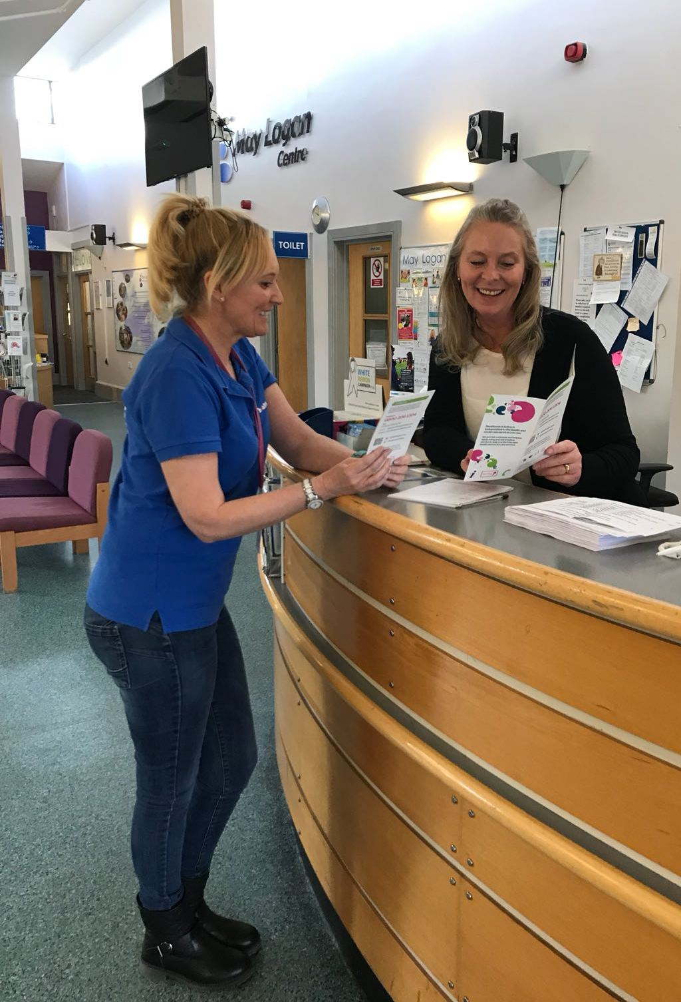
Healthwatch Sefton Feedback Report
December 2017 – February 2018
Family Planning Clinic, May Logan Centre
Provided by Southport & Ormskirk NHS Hospital Trust

Contents page
 | Page Number
Healthwatch Sefton | 3
Healthwatch Sefton Feedback Centre | 4
Key Points | 5
Snapshot | 6
Key Themes | 7 - 13
Reviews | 14 - 21
Summary, Recommendations & Questions | 22 - 23
Acknowledgements | 23
Response from Southport & Ormskirk NHS Hospital Trust | 24 - 25
Contact us | 26
Healthwatch Sefton Feedback form | 27 - 28
Control sheet | 29

Healthwatch Sefton
Healthwatch Sefton exists to make health and social care services work for the people who live in Sefton or use services based in Sefton.
Everything we say and do is informed by our connections to local people. Our main aim is understanding the feedback and concerns of people of all ages who use services, and to speak out on their behalf.
Our role is to ensure that local decision makers and health and social care services put the experiences of local people at the heart of their work. We believe that asking people more about their experiences and encouraging them to feedback can identify issues that, if addressed, will make services better.
Healthwatch Sefton is set up as a private company limited by guarantee, a subsidiary company of Sefton Council for Voluntary Service (Sefton CVS). There is a small staff team and a large team of volunteers who work together to ensure the organisation works towards it strategic and local priorities.
We are uniquely placed as we have a national body, Healthwatch England. Both organisations have significant statutory powers to ensure that the voice of people who want to have a say about health and social care services is strengthened and heard by those who commission, deliver and regulate health and social care services.
Healthwatch Sefton works with Healthwatch England to ensure the voice of Sefton residents is represented at a national level. Healthwatch England picks up national issues and works with Healthwatch Sefton to help provide a national picture. We also work as part of a regional North West Healthwatch Network.

Healthwatch Sefton Feedback Centre
This report details the feedback, which patients, family, visitors and staff have shared with us on The May Logan Centre, Family Planning Clinic. The Provider for this service is Southport & Ormskirk NHS Hospital Trust. The feedback shared with us has been added to the Healthwatch Sefton Feedback Centre. This web based tool helps members of the public to rate the services they use and provides Healthwatch Sefton with real time experiences which help to identify trends and issues which
we can act on.
The majority of the feedback we receive is through the engagement and outreach activities which we undertake across Sefton. For example, we hold engagement stands at local events, attend groups and talk to people and we hold engagement stands at local hospitals and local health centres.
For this report Healthwatch Sefton attended The May Logan Centre in Bootle and spoke to patients, family, visitors and staff within the main reception area to find out what they like about the Family Planning clinic and what improvements they would like to see. This work was carried out by Healthwatch Sefton in partnership with Southport & Ormskirk NHS Hospital Trust and the May Logan Centre.
We continue to engage with our community and record all feedback by using the feedback forms (Appendix 1). This information is then entered onto the Healthwatch Sefton Feedback Centre.
All of the feedback received within this report is the actual wording of the people we have spoken with/ as shared online. The only exception to this is if the person can be individually identified by what has been written. If any individual has been spoken about negatively their name will be removed.

Key points

- 44 reviews / feedback forms were received between December 2017 to February 2018.

- Family Planning services provided at the May Logan Centre achieved an average Healthwatch Sefton rating of 4.5 stars out of 5 stars.

- Staff ‘Attitude’ achieved 100% positive feedback.

- ‘Quality’ of Treatment & Care achieved 100% positive feedback.

- Access to services -‘Service Delivery / Opening times’ 50% of the reviews were positive and 50% were negative.

- Access to services – ‘Waiting times’ 58% of the reviews were negative with 27% positive.

- Convenience / Distance to travel achieved 100% positive feedback.

- Young people and youth outreach workers when spoken to asked for sexual health services to be delivered in a local youth & community setting.

Snapshot
The following information provides a snapshot of information provided between December 2017 – February 2018. During this period Healthwatch Sefton gathered 44 completed feedback forms relating to the Family Planning clinic based at the May Logan Centre, Bootle.
As can be seen from the information below the Family Planning service has scored an average Healthwatch Sefton rating of 4.5 stars out of 5 stars between the periods of December 2017– February 2018. The sentiment of the reviews / feedback are analysed as being an average of 77% positive, 5% negative and 18% neutral.

Key Themes
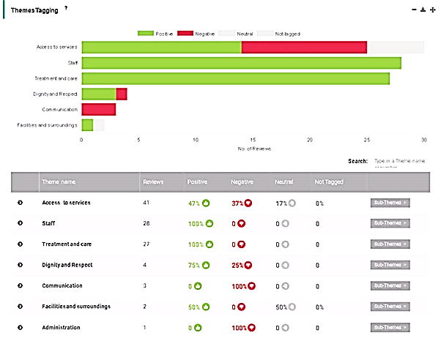

During December 2017 – February 2018 there were a total of 44 feedback forms / reviews completed.
The above table shows the main areas of feedback received is themed around:
‘Access to Services’ with 41 reviews achieving 47% positive feedback, 37% negative feedback and 17% neutral feedback.
‘Staff’ was the second highest feedback received with 28 reviews resulting in 100% positive feedback.
‘Treatment and Care’ also achieved 100% positive feedback with 27 reviews recorded.
All feedback / reviews can be found under the ‘Reviews’ section of this report.

Access to Services
‘Access to Services’ has been broken down into sub themes as can be seen in the below table:
Sub themes
Waiting times – 58% of reviews were negative, 27% of reviews were positive and 15% of the reviews were neutral comments. Please see below for some of the feedback received:
‘I came in for injection, it is well organised, however then can be long waits. I do appreciate the demand’.
‘Overall I am pleased with my visit. Reception staff are polite and efficient. I would prefer a booking system as I work full time so have to allow up to 1 1/2 hours out of the office which isn't always very well received’.
‘Long waiting times but when you are seen the nurses are always lovely and make you feel comfortable, always very helpful’.
Afternoon / evening clinics – ‘If you do not arrive within first 30 minutes or so of the drop-in slot you are often turned away as already too many people to be seen’.
‘Excellent service and very informative. Really helpful and fairly quick service’.

A separate piece of outreach was carried out by Healthwatch Sefton during January – February 2017 were waiting times was also highlighted as an issue at the clinic.
Please see the ‘Reviews’ section for all reviews December 2017 – February 2018.

Convenience / Distance to travel to - achieved 100% positive feedback with comments including:
‘Very helpful and I have had information I hadn't known to give me better options.
The May Logan is only 10 mins away’.

Afternoon clinic ‘This is a good service. Depends when you come as I have waited a long time when I have come. The staff are nice and it is local to get to’.

Please see the ‘Reviews’ section for all reviews December 2017 – February 2018.

Service Delivery / Opening times – achieved 50% positive feedback and 50% negative feedback. Comments included:
Afternoon / evening clinics – ‘If you do not arrive within first 30 minutes or so of the drop-in slot you are often turned away as already too many people to be seen’.
Afternoon clinic – ‘Staff are always friendly and helpful. Confidentiality is always kept and they are always discreet.
Depending on the time of day the waiting times vary but that can only be expected. I have never had a problem with the service. I like the way there is a choice of different days for family planning so it is not restricted’.

Evening clinic: ‘It is convenient, fair booking in system although sometimes long waiting times.
You have to arrive early if you want to be guaranteed to be seen. The staff are friendly and helpful’.

It is important to note that during previous outreach held at the May Logan Centre Family Planning clinic between January 2017 – February 2017 it was also commented on about the drop-in clinics having to close early due to reaching the maximum number of patients; this was commented on by both patients and staff. 12 patients was quoted as being the maximum number to be seen during a clinic and patients were being advised to get to the clinic early to ensure they were seen. 10 of the 26 feedback forms during this period mentioned this as an issue.
Please see the ‘Reviews’ section for all reviews December 2017 – February 2018.

Staff
‘Staff’ has been broken down into sub themes as can be seen in the below table:
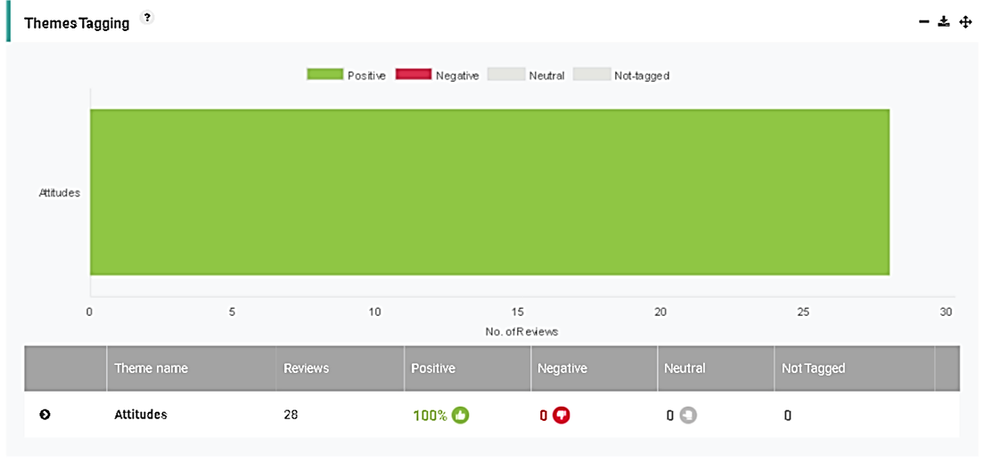
The Family Planning services at the May Logan Centre achieved 100% positive feedback in relation to staff attitude. A total of 28 reviews were received. Some of the feedback recorded is below:
‘Great service. I was having the coil removed. I was a bit nervous at first with it being a male doctor but there was a lady present too and both made me feel at ease and were both lovely and professional’.
‘Friendly staff, supportive and give useful advice. The waiting times can often be long’.

Evening clinic – ‘Good experience. The nurse was lovely. She was very helpful, gave good advice and was caring’.

‘The staff are always pleasant, helpful and professional’. I am happy with everything. They have provided what I needed when I needed it’.

Please see the ‘Reviews’ section for all reviews December 2017 – February 2018.

Treatment & Care

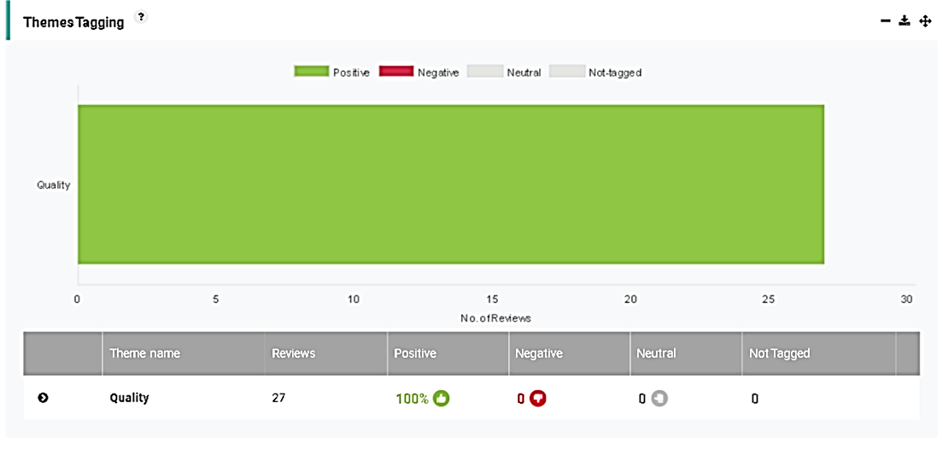

The Family Planning services at the May Logan achieved 100% positive feedback in relation to ‘Quality’ of Treatment & Care. In total 27 reviews were received. Some of the feedback recorded is below:

Evening clinic: ‘Always a good experience. Only come here to access the PACE clinic’.

Evening clinic: ‘I got the advice I needed’.

Afternoon clinic ‘Brilliant, a little wait but worth it. The staff are really friendly’.

‘Very quick and not embarrassing. It was my first time here, felt nervous but made to feel comfortable’.

Please see the ‘Reviews’ section for all reviews December 2017 – February 2018.

Youth & Community Centre

On 1st February 2018 Healthwatch Sefton visited a local youth and community centre in Bootle to chat with young people along with outreach workers to find out their views on accessing local family planning / sexual health services. The group included:

- 4 young females
- 2 outreach workers

Feedback received from the group is below:

‘We used to have sexual health clinics at the Brunswick Youth & Community Centre. The nurse stopped coming here approx 6 months ago. No one was told the service had stopped’.
.
‘We don't want to be seen at the May Logan, it can get really busy in there’
.
‘There are now no chemists around here who offer injections or pill for free.
We have to now go to either the May Logan or Liverpool. When we used to be able to go to Park Street it was secluded’
.
‘There are long waiting times at the May Logan and people can know you’.

‘There used to be a sexual health nurse on girls night at the Brunswick on a Wednesday’.

‘One young person who comes in the Brunswick still has problems but will not go the May Logan’.

‘One of our friends told us on Monday she went the May Logan but the waiting was too long and she was turned away. It puts us off going in case we are turned away’
.
‘One time I went there and a man was going to inject me in my bum, I didn't realise I would be getting a male but I asked for a female and they did agree to this’
.
‘We all feel it would be better to have a nurse come to the community centre’.

Waiting times, confidentiality / privacy and the thought of being turned away at the May Logan Centre was a particular barrier for the young people in accessing the services. All 6 group members felt there was a need for a nurse to offer sexual health services within a local community setting.

Reviews

A total of 44 reviews / feedback forms were received between the period of December 2017 to February 2018. The following Healthwatch Sefton Star rating was used:
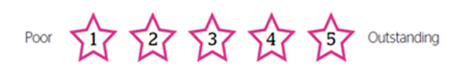

Rating | Title | Review
5 | Excellent service | Excellent service and very informative.  Really helpful and fairly quick service.
5 | Great service | Great service. I was having the coil removed. I was a bit nervous at first with it being a male doctor but there was a lady present too and both made me feel at ease and were both lovely and professional.
5 | Service works well | Service works well, it is good to have it. You can come in for anything. Waiting times have not been too bad and it is local to get to.
5 | Can be long waits | I came in for injection, it is well organised, however then can be long waits. I do appreciate the demand.
4 | Overall pleased with visit | Overall I am pleased with my visit. Reception staff are polite and efficient. I would prefer a booking system as I work full time so have to allow up to 1 1/2 hours out of the office which isn't always very well received.
5 | Very professional | Great, even though it was busy I was seen to relatively quickly. Very professional.
5 | Discreet service. | Discreet service.
4 | Waiting times can be long | Friendly staff, supportive and give useful advice. The waiting times can often be long.
5 | Very helpful staff | Very helpful and I have had information I hadn't known to give me better options.  The May Logan is only 10 mins away.
5 | Very quick service | Very quick and not embarrassing. It was my first time here, felt nervous but made to feel comfortable.
2 | Group feedback on service | Group feedback from 4 young people and 2 outreach workers.  We used to have sexual health clinics at the Brunswick Youth & Community Centre. The nurse stopped coming here approx 6 months ago. No one was told the service had stopped.  We don't want to be seen at the Mag Logan, it can get really busy in there.  There are now no chemists around here who offer injections or pill for free.  We have to now go to either the May Logan or Liverpool. When we used to be able to go to Park Street it was secluded.  There are long waiting times at the May Logan and people can know you.  There used to be a sexual health nurse on girls night at the Brunswick on a Wednesday.  One young person who comes in the Brunswick still has problems but will not go the May Logan.  One of our friends told us on Monday she went the May Logan but the waiting was too long and she was turned away. It puts us off going in case we are turned away.  One time went there and a man was going to inject me in my bum, I didn't realise I would be getting a male but I asked for a female and they did agree to this.  We all feel it would be better to have a nurse come to the community centre.
4 | Waiting times are extreme | Waiting times are extreme.
4 | The staff are nice | I have come for my injection. The staff are nice. Sometimes you can wait a while. They do explain everything to me. I only live local.  Waiting times could be improved.
5 | Staff are very professional | The staff are very professional. Dignity and confidentiality are maintained. Advice given is correct and to NICE guidelines.  Coil removal - staff caring, gentle and competent.  Being able to book time slots would be more beneficial for the employed.
5 | Works well for me | Clinic works well for me and is local. It is a free service too.  It is 10.30 am now and looks busy so not sure if I can wait as I have to go into work. It is good though that it is a drop-in.  They could do with more doctors and nurses to help with the waiting times.  I would have preferred to go to the PACE clinic but they closed it there.
4 | Staff friendly | Fast, efficient and great advice.  Friendly reception staff made it clear what to do and go about it.  Nurses are always well mannered and make you feel comfortable.
5 | Happy with everything | The staff are always pleasant, helpful and professional.  I am happy with everything. They have provided what I needed when I needed it.
4 | Friendly staff | My experience has been quite pleasant with friendly staff and I have always been seen fairly fast.
5 | Friendly staff | Friendly staff that made me feel comfortable.  It was my first time at the clinic so was a bit anxious beforehand but all the staff, receptionists and nurses were lovely and gave me all the necessary information.
4 | Friendly staff | Friendly staff, service ok.
4 | Long waiting times | Long waiting times but when you are seen the nurses are always lovely and make you feel comfortable, always very helpful.  Afternoon / evening clinics - If you do not arrive within first 30 minutes or so of the drop-in slot you are often turned away as already too many people to be seen.
4 | Staff very helpful and friendly | When walking into the building the staff were very helpful and friendly (non judgmental)  I found the visit very personable and relaxing. Staff so helpful.
4 | I have to use this service | I am a patient at the Strand Medical Centre. They have no nurse on this week, this has happened before. I had to change what contraception I was using because of them. They have said they don't have a nurse that can now provide this service. The nurse situation has been long term here.  This is my first time to attend the family planning clinic at the May Logan. I telephoned the May Logan last night and they told me the clinic was 1 - 7 pm today but to get here early as I could because of staffing.  I also could not get my injections that I needed at the Strand Medical Centre for the same reason, no nurse. There were 17 of us who were told no at the surgery.
2 | Drop-in is not ideal | Afternoon clinic  The drop-in is not ideal. As being called at random due to the skill set of the staff.  I have waited one and a half hours and may not get to be seen as I have to go and collect my daughter from school at 3pm
4 | Waiting times | Afternoon clinic  I have been waiting to be seen 1 hour and 15 mins. The nurse comes out to call numbers and calls 486 when I am 484 and been waiting all this time. For someone who has only been there 5 minutes to be seen who no explanation as to why this has happened.
3 | Communication issue | Afternoon clinic  I have waited for over an hour then people who had been there 10 mins went in before me which did upset me.  I think you could do with more chairs.
4 | The staff are nice | Afternoon clinic  This is a good service. Depends when you come as I have waited a long time when I have come. The staff are nice and it is local to get to.
5 | They are really good here | Afternoon clinic  I have an appointment to have a coil fitted. I come here from Kirkby because they are really good here.  Note: unable to finish questionnaire as patient called in.
5 | Staff are always friendly and helpful | Afternoon clinic  Staff are always friendly and helpful. Confidentiality is always kept and they are always discreet.  Depending on the time of day the waiting times vary but that can only be expected. I have never had a problem with the service. I like the way there is a choice of different days for family planning so it is not restricted.
4 | Staff very pleasant | Afternoon clinic  I find the staff at the centre very pleasant and the service is always efficient. I also like that you can check on-line for opening times.  I always come to get my contraception implant replaced. The staff are very chatty and informative.
5 | The staff are good | Afternoon clinic  I came here 6 months ago. The male nurse gave me 6 months worth of contraception so I did not have to come back so frequently. I waited approx half an hour and considering this is a drop in I don't think that is too bad.  I am accessing the drop in today. The staff are good. I have come at this time (3.15 pm) as it is school pick-up time, therefore not busy.
5 | Staff really friendly | Afternoon clinic  Brilliant, a little wait but worth it. The staff are really friendly.
4 | Long waiting times in past | Afternoon clinic  I have been here twice before. There have been long waiting times but no-one is here today.  Note: Patient called in unable to finish form
5 | Recommended by a friend | Evening clinic:  I have been here before and it is all great. I was recommended by a friend to come here. The staff are nice and explain everything. We came in on a Friday last time and waited about 2 hours to be seen.  I like the way it is really confidential.
5 | Always a good experience | Evening clinic:  Always a good experience. Only come here to access the PACE clinic.
4 | Fair booking in system | Evening clinic:  It is convenient, fair booking in system although sometimes long waiting times.  You have to arrive early if you want to be guaranteed to be seen. The staff are friendly and helpful.
5 | Nurse was really nice | Evening clinic:  Both times I have been I have had an appointment straight away. May Logan is only 10 mins away. The nurse the last time I was here was really nice. I had an appointment last time and was seen straight away. The Southport service is awful, that has long waiting times even with an appointment.
5 | Really helpful staff | Visit October 2017 - Really helpful staff. The nurse was excellent and put me at ease straight away. The waiting was a while but worth it.
4 | Staff are friendly and helpful | Evening clinic:  Staff are friendly and helpful. Waiting time can be sometimes a little long but the procedures themselves are carried out quickly and efficiently.  Good advice most of the time (on first visit was recommended injection which wasn't the best outcome.
4 | Good experience | Evening clinic  I found my experience at the May Logan good. Depending on how busy they are the service they provide is good.  I have not had to wait long for any of my appointments.
5 | Efficient and helpful | Evening clinic:  Very clean. Efficient, helpful and friendly staff.
5 | The nurse was lovely | Evening clinic  Good experience.  The nurse was lovely. She was very helpful, gave good advice and was caring.
5 | I got what I needed | Evening clinic:  I got what I needed (August 2017)
5 | I got the advice I needed | Evening clinic:  I got the advice I needed.

Summary, Recommendations & Questions
Good Practice

The May Logan Family Planning services provided by Southport & Ormskirk NHS Hospital Trust scored an average Healthwatch Sefton rating of 4.5 stars out of 5 stars.

The majority of positive reviews related to:

- Quality of Treatment & Care

- Staff attitudes

- Distance / Convenience to travel

Recommendations / Questions

Access to services:

- In view of the feedback received regarding drop-in clinics not staying open for the allotted time and patients being turned away can the Trust advise if this has already been identified as an issue and what if any plans are in place to minimise this in the future?
- To consider re-introducing the sexual health service /nurse at a local youth and community setting.
- It was noted during the outreach that the PACE clinic was temporarily moved to the May Logan Centre from Park Street clinic. To advise if the PACE clinic will remain at the May Logan Centre for the foreseeable future?

Communication:

- To have a system in place to inform patients that they may be called in a different order to that of arrival depending on what service they are accessing e.g. if they have a set appointment.

Acknowledgements

Healthwatch Sefton would like to thank Southport & Ormskirk NHS Hospital Trust for working in partnership with Healthwatch Sefton in ensuring patient, family, visitor and staff voices are heard and listened to.

We would like to thank all the staff that work at the May Logan Centre and to the patients, family and visitors who took the time to complete the feedback questionnaire.

Response from Southport & Ormskirk NHS Hospital Trust

The following response was received 27th March 2018 from Wendy Hicks, Matron for Sexual Health services:

Responses to questions from Healthwatch Sefton Feedback report –
Family Planning services, May Logan Health Centre

- In view of the feedback received regarding drop-in clinics not staying open for the allotted time and patients being turned away can the Trust advise if this has already been identified as an issue and what if any plans are in place to minimise this in the future?

The issue of the clinic not staying open for the allotted time has been identified by the service plans to improve this include:

Recording turned away patients to ensure demand is captured to allow us to increase capacity going forward.

Review of staffing skill mix to ensure appropriate staff are rostered to work in the clinic when it is open.

Review of how service is run to establish potential to implement a combination of appointments and walk in services.

The May Logan Centre has been approached to identify if there is further room availability to be able to increase services.

We will review sessions to establish whether they are being utilised to capacity at quieter times to see how capacity can be increased when demand is greater.

- To consider re-introducing the sexual health service /nurse at a local youth and community setting.

We have previously offered these services at a number of youth centres and Children’s centres across Sefton however there was very little activity generated we continue to provide a clinical outreach service that all partner agencies are aware of and can refer in to.

We will re-advertise and promote this service to ensure that it is widely publicised.

- It was noted during the outreach that the PACE clinic was temporarily moved to the May Logan Centre from Park Street clinic. To advise if the PACE clinic will remain at the May Logan Centre for the foreseeable future?

As part of the new specification the offer of services to under 20’s has been identified as an area of focus for us.

The relaunch of the PACE service is planned under the new contract at our services across Sefton. These will be dedicated young people’s services within HUB clinics providing access Contraception and Sexual Health Services.
We are scoping the provision of young people’s services within 0-19 services in Sefton.

- To have a system in place to inform patients that they may be called in a different order to that of arrival depending on what service they are accessing e.g. if they have a set appointment.

There are currently signs to say that patients will be called out of turn depending on what they are attending for and where they are located within the clinic by reception and in the waiting area – we will review these posters to see if they can be made more noticeable.

Staff advise patients as they call them advising why they may have been called out of turn.

We have asked reception staff to advise patients that they may be called out of turn to ensure that they are seen by the most appropriate person.

We have added the following message to the website:

Please be aware that sometimes patients are not called in to see the nurse or doctor in the order that they arrive. This happens so that we can allocate the appropriate staff to the requested need of each patient.

to increase awareness of the process in all of our clinics before they attend.

Contact us

Address: Healthwatch Sefton, Sefton Council for Voluntary Service (Sefton CVS), 3rd Floor, Suite 3B, North Wing, Burlington House, Crosby Road North, Waterloo, Liverpool L22 0LG
Phone number: 0151 920 0726 (ext 240)
Freephone: 0800 206 1304
Text: 07434 810438
Email: info@healthwatchsefton.co.uk
Website: www.healthwatchsefton.co.uk

@HWatchSefton
@HWSFindServices

www.facebook.com/healthwatchsefton2013/

Please use our star rating system, where for example, a 1 star rating would be the worst/least agree, 3 would be a middle/medium rating, and 5 would be the best possible rating.
Approx. Date of Experience

How do you rate your overall experience of this service?
Summary of your experience (max 45 characters)

Tell us more about your experience*

Where do you live? (town/city)

Which department did you visit?

Your ratings (select if applicable)

Quality of treatment
Staff Attitude
Cleanliness
Quality of Food & Drink (if Applicable)
Communication
Discharge
Quality of Environment
Appointment (waiting times)
In relation to your comments are you a…
Patient/Carer/Friend/Staff Member/Other (describe)

Do you want to know more about how to make an official complaint?
Yes/No

About you
Name:
Address:
Email/Number if want to leave*
(Your email/number will be kept private and you will not be sent any marketing material)

Date Submitted: | 28th February 2018
Date Response Due: | 29th March 2018
Date Response Received:
Follow up action:

Submitted to:

Trust
NHS South Sefton and Southport & Formby CCG Accountable Officer
NHS South Sefton and NHS Southport & Formby CCG Lead Nurse
NHS South Sefton and NHS Southport & Formby CCG Lay Advisors
NHS South Sefton and NHS Southport & Formby CCG Engagement lead
Local Authority (Sefton MBC) commissioner
Cabinet Member for Health & Social Care
NHS England Quality Surveillance Group
Healthwatch Sefton Steering Group
Healthwatch Sefton website.

